Dynamic Programming

Practice problems:

PROBLEM 01. Fibonacci number

Pseudocode (Naive Recursion):
Function Fib(n):  - if n==0 or n==1 then  - return n  - end if  - return Fib(n-1) + Fib(n-2) | Time complexity: O(2^n)  Space complexity: O(1)

DP Pseudocode (Memoization/Top-down):
Create array F[0…n] = NIL  F[0]=0, F[1] = 1  Function Fib(n):  - if n==0 or n==1 then  - return n  - end if  - if F[n-1] = NIL then  - F[n-1] = Fib(n-1)  - end if  - if F[n-2] = NIL then  - F[n-2] = Fib(n-2)  - end if  - return F[n-1]+F[n-2] | Time complexity: O(n)  Space complexity: O(n)

DP Pseudocode (Tabulation/Bottom-up):
Function Fib(n):  - Create array F[0…n]  - F[0]=0, F[1] = 1  - for i = 2 to n do  - F[i] = F[i-1]+F[i-2]  - end for  - return F[n] | Time complexity: O(n)  Space complexity: O(n)

DP Pseudocode (Problem-specific optimization):
Function Fib(n):  - f0=0, f1=1  - for i = 2 to n do  - f2 = f0+f1  - f0 = f1  - f1 = f2  - end for  - return f1 | Time complexity: O(n)  Space complexity: O(1)

PROBLEM 02. Coin change problem
Consider the problem of making changes for M cents using the smallest number of coins. There are d types of coins C = {c₁, c₂, …, c_{d}}, each coin’s value is an integer, and there are an infinite number of coins for each coin type. Write a dynamic programming algorithm to make change consisting of coins in C.
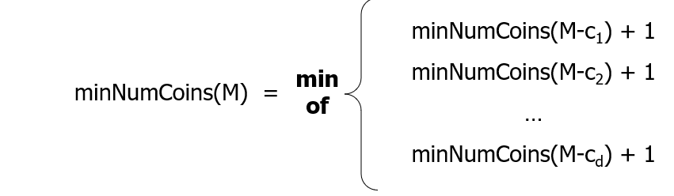

Pseudocode (Naive Recursion):
Function Recursive-Change (M, C, d):
- if M = 0 then
- return 0
- end if
- mnc = infinity // minimum number of coins
- for i = 1 to d do
- if C[i] <= M then
- nc = Recursive-Change(M-C[i], C, d)
- if nc+1 < mnc then
- mnc = nc+1
- end if
- end if
- end for
- return mnc

Pseudocode (Tabulation method):
Function Coin-Change (M, C, d):
- create an array mnc[0…M]
- mnc[0] = 0
- for m = 1 to M do
- mnc[m] = infinity
- for i=1 to d do
- if C[i] <= m and mnc[m-C[i]]+1 < mnc[m] then
- mnc[m] = mnc[m-C[i]]+1
- end if
- end for
- end for
- return mnc[M]

Sample Input:
4 11
1 5 6 8
Explanation:
Number of coins = 4
Target amount = 11
Coin denominations = 1, 5, 6, 8
Expected output:
2

Food for thought:
How to print the coins taken?

Alternative Problem 2.2
Consider the problem of making an M-meter-long rope using smaller ropes. There are d types of ropes C = {c1, c2, …, cd}, each rope’s value is an integer, and there are an infinite number of ropes for each rope type. Joining two ropes together costs X dollars. Write an algorithm to make an M-meter-long rope at a minimum cost.

PROBLEM 03. Rod cutting
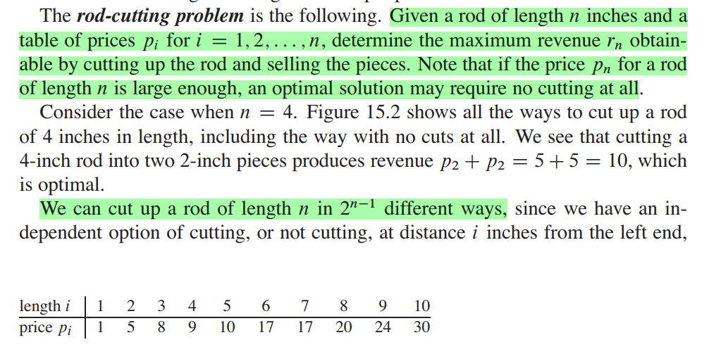

Pseudocode (Naive recursion):
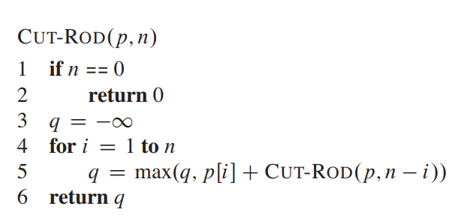

Pseudocode (Tabulation method):

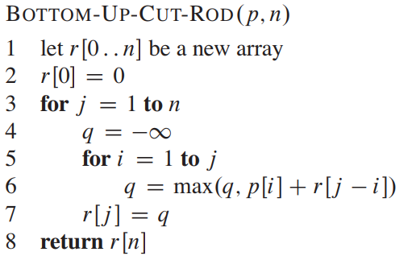

Pseudocode (Tabulation method):

Function Rod-Cutting (p, n):
- create an array r[0…n]
- r[0] = 0
- for rodlen = 1 to n do
- r[rodlen] = - $∞$
- for cutlen = 1 to rodlen do
- if p[cutlen]+r[rodlen-cutlen] > r[rodlen] then
- r[rodlen] = p[cutlen]+r[rodlen-cutlen]
- end if
- end for
- end for
- return r[n]

Food for thought:
How to print the rod cuts?

PROBLEM 04. 0-1 Knapsack
The weights and values of n items are given. The items are not divisible, i.e., you cannot take a fraction of an item. You have a knapsack to carry those items, whose weight capacity is W. Due to the capacity limit of the knapsack, it might not be possible to carry all the items at once. In that case, pick items such that the profit (total value of the taken items) is maximized.
Write a program that takes the weights and values of n items, and the capacity W of the knapsack from the user, and then finds the items that would maximize the profit using a dynamic programming algorithm.
sample input  n  weight, value  …  W | sample output
4  4 20  3 9  2 12  1 7  5 | item 1: 4.0 kg 20.0 taka  item 4: 1.0 kg 7.0 taka  profit: 27 taka

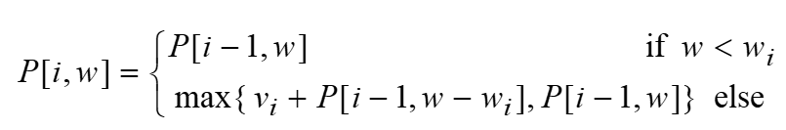

Pseudocode (Tabulation method):
Function Knapsack( v[], w[], W):  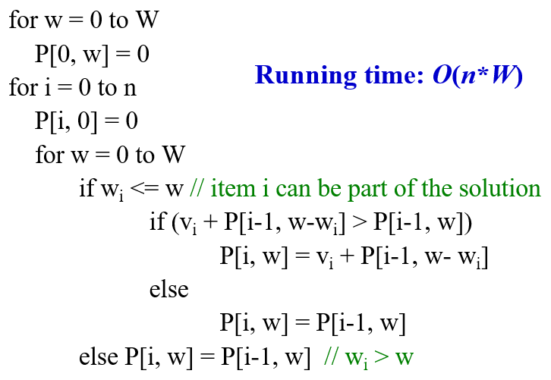 | 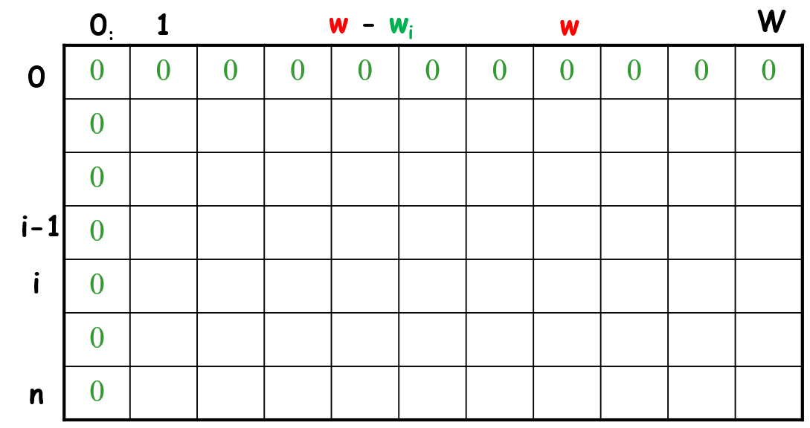  Time complexity: O(nW)  Space complexity: O(nW)

Sample input:
4 8

3 30

4 50

5 60

2 20
Explanation:
- 4: Number of items.
- 8: Knapsack capacity.
- Then for each item:
  - 3 30: Item 1 → weight = 3, value = 30
  - 4 50: Item 2 → weight = 4, value = 50
  - 5 60: Item 3 → weight = 5, value = 60
  - 2 20: Item 4 → weight = 2, value = 20
Expected output:
90

Food for thought:

How to print the items taken?

PROBLEM 05. Subset sum problem
You are given an array A and a number N. You need to find out whether N is a sum of any subset of A.
Example:
A = {2, 4, 5, 6, 8}, N = 15 🡪 True {4, 5, 6}
A = {2, 4, 5, 6, 8}, N = 0 🡪 True {}
A = {2, 4, 5, 6, 8}, N = 3 🡪 False

Hint: similar to 0-1 knapsack. Think of A as a set of items, and N as knapsack capacity.

Food for thought:

How to print the numbers taken?

PROBLEM 06. Longest common subsequence

Given two strings x and y, find the longest common subsequence and its length.
Example:

x = “ABCBDAB”
y = “BDCABA”
longest common subsequence = “BCBA”
longest common subsequence length = 4

x = “ABBACQ”
y = “XAYZMBNNALQCTRQ”
longest common subsequence = “ABACQ”
longest common subsequence length = 5

Hint: CLRS 15.4

DP equation:
if(A[i] = B[i]){
LCS[i,j] = 1 + LCS[i-1, j-1]
}
else{
LCS[i,j] = max(LCS[i-1, j], LCS[i, j-1])
}

